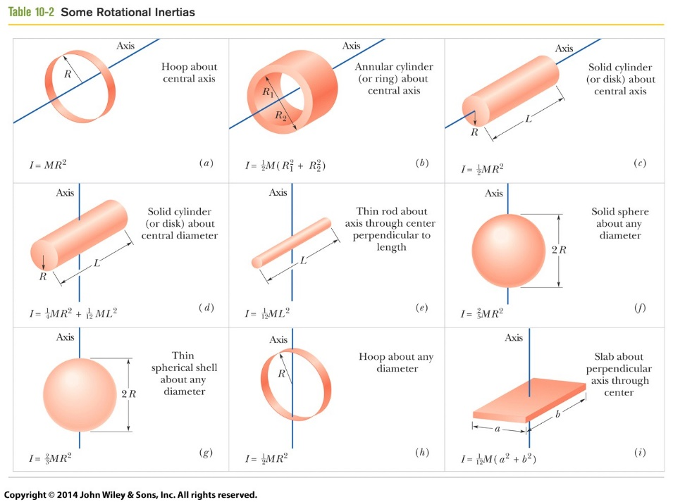

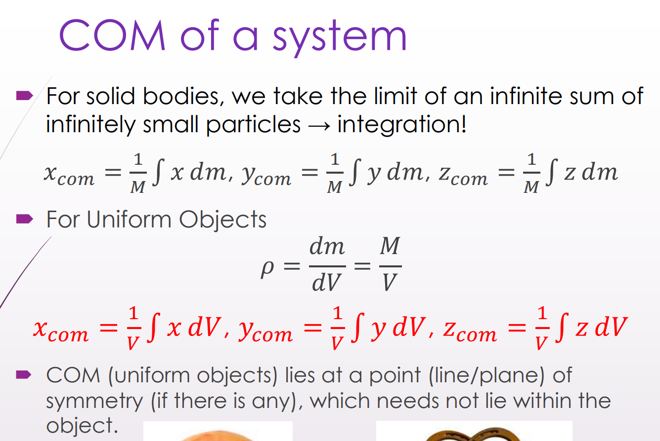
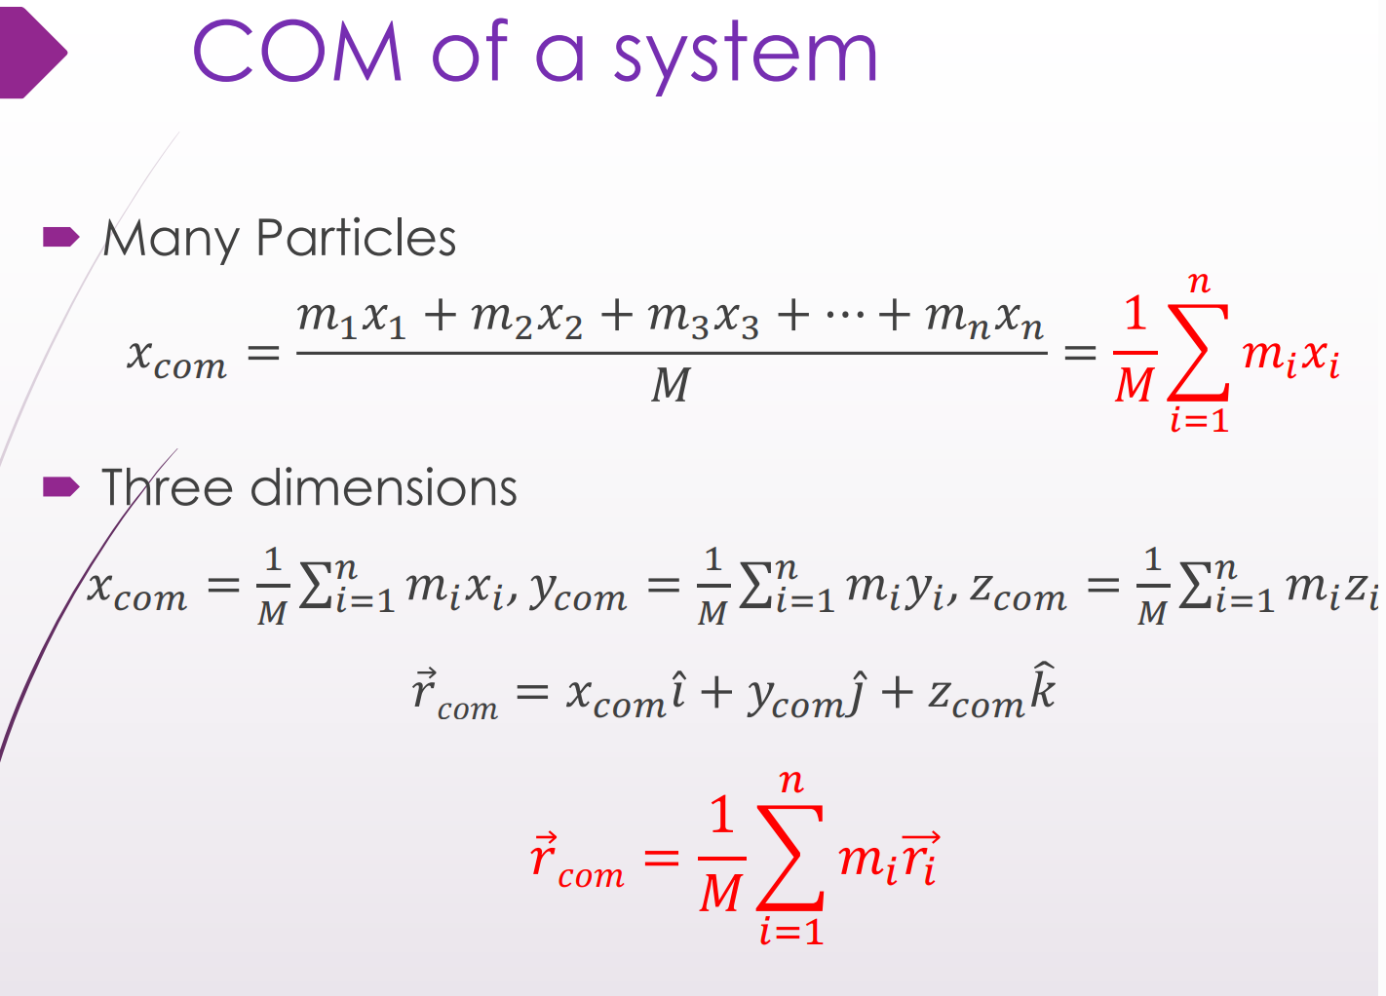
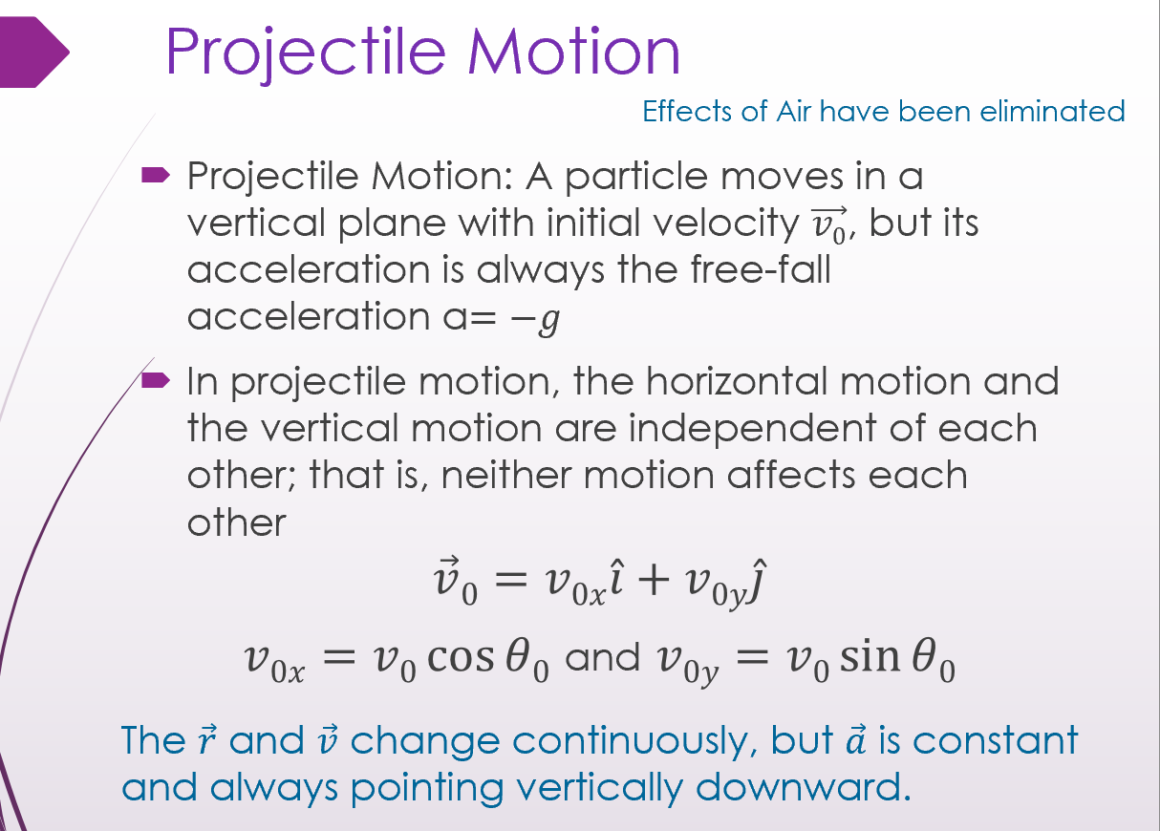
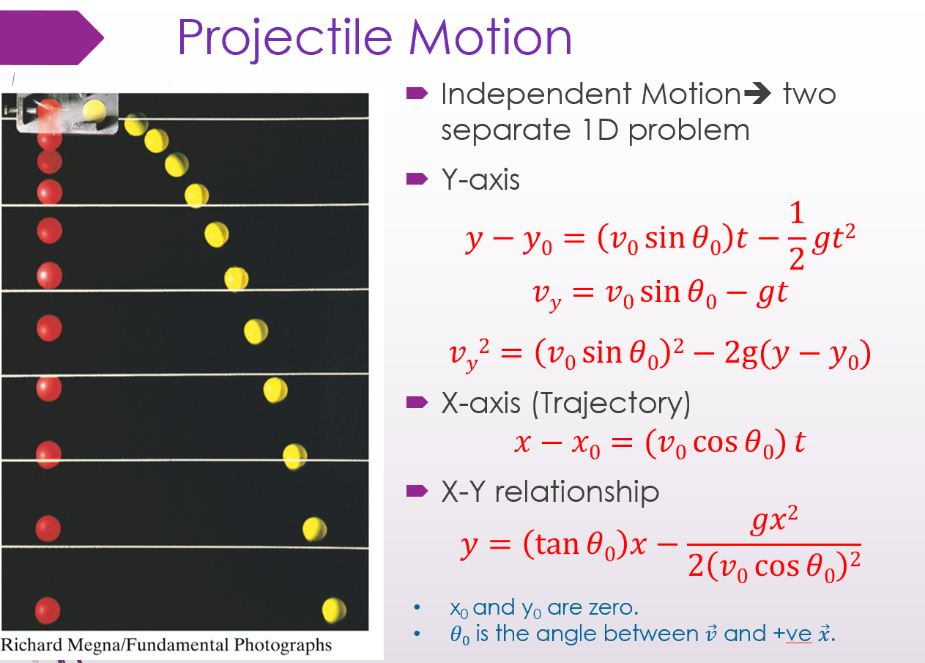

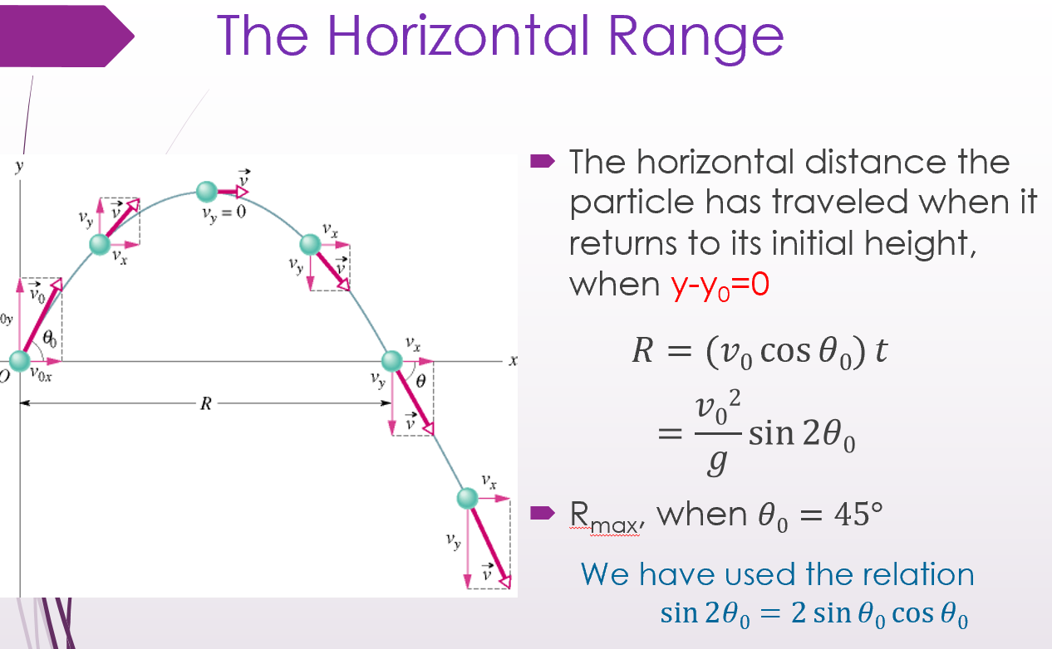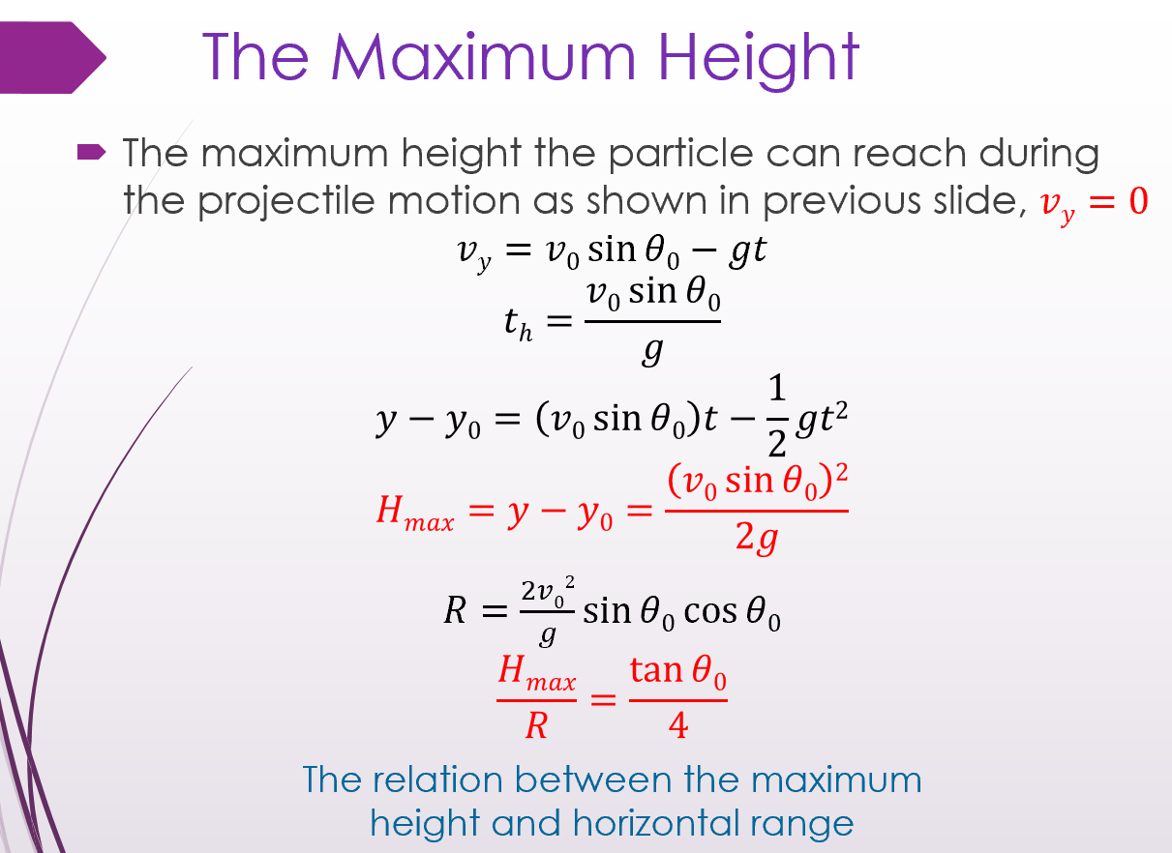
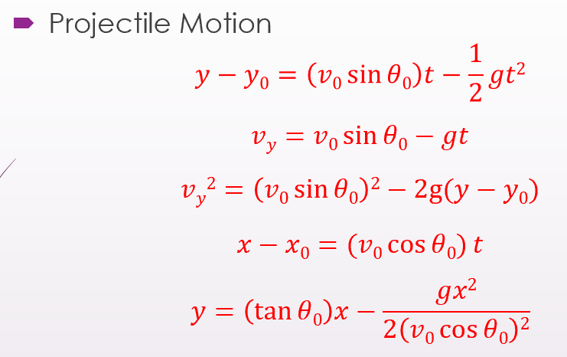
周期 T: The period of revolution or simply period
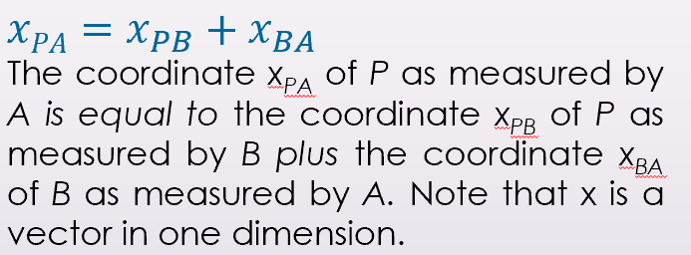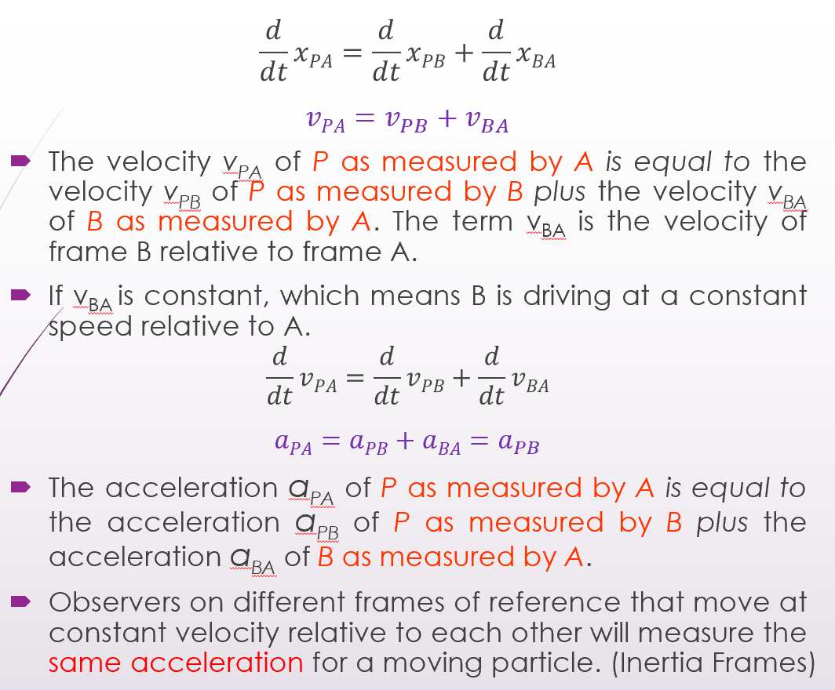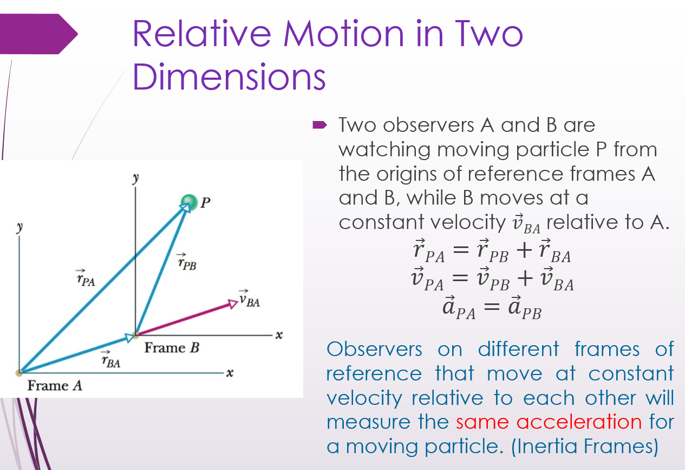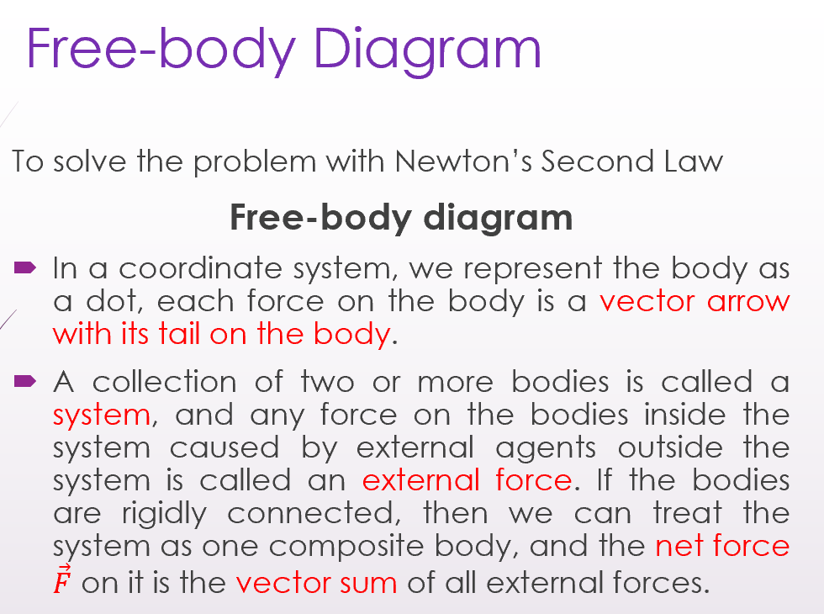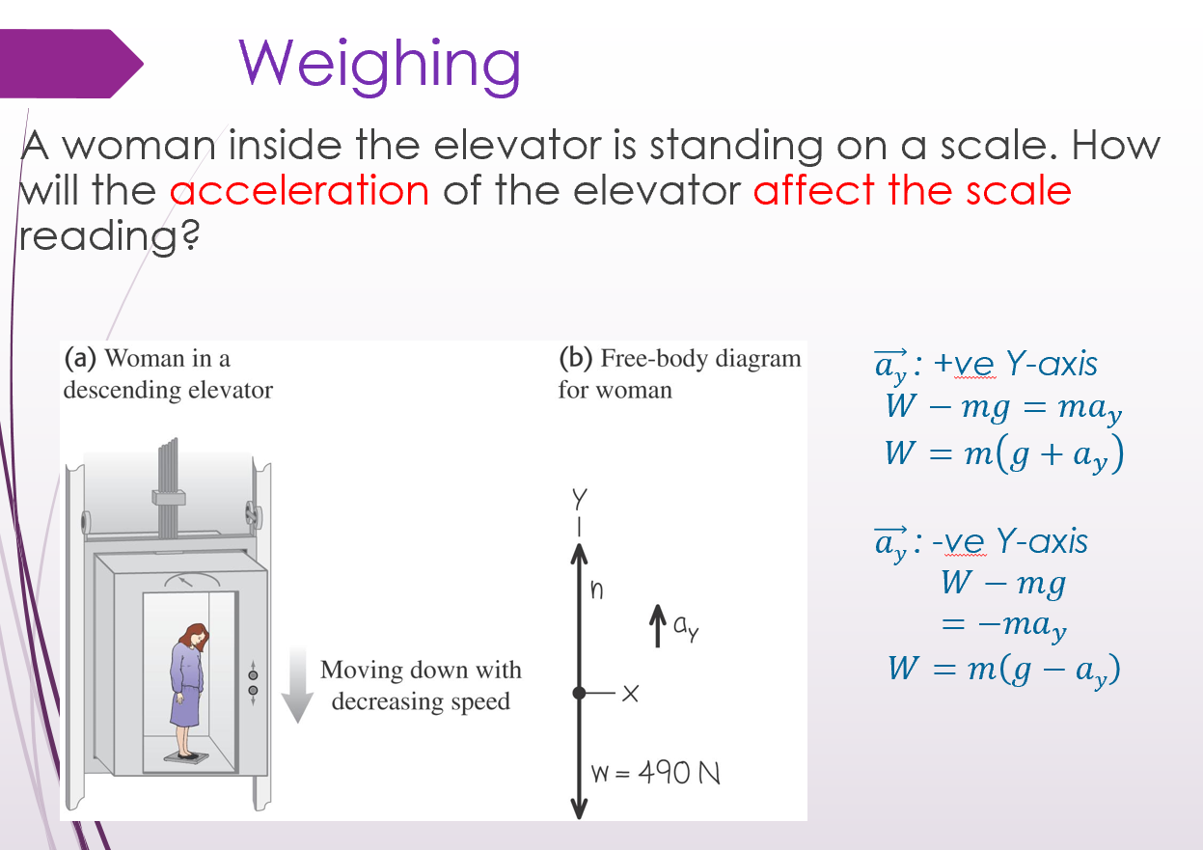
Drag Force ($\vec{D}$) 拖拽力
Def.: When there is a relative velocity between a fluid and a body, the body experiences a drag force.
Direction: Opposes the relative motion and points in the direction in which the fluid flows relative to the body.
·$D=\frac{1}{2} C ρ A v^{2}$
C: drag coefficient
(C: Typical values range from 0.4 to 1.0; and we use it as constant here. )
ρ: air density
A: effective cross-sectional area
(perpendicular to the velocity)
v: relative speed
( Drag force是指当一个物体相对于周围流体运动时，与其相反的作用力。这种力可以存在于两个流体层（或表面）之间，也可以存在于流体和固体表面之间。当物体在流体中移动时，流体会产生阻力，称为拖曳力或拖曳。它与物体的运动方向相反，并由固体物体和流体之间的相对速度产生。 )
-Terminal Speed (v_{t}) 终端速度
Def.: When a blunt body falls from rest through air, If |D| = |mg|, then the body’s speed is constant (the acceleration a=0),
which is called terminal speed v_{t}
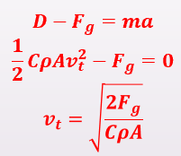 (a=0)
-Uniform Circular Motions
Centripetal force 向心力
Magnitude: (F=ma, Magnitude of the acceleration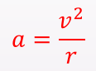)
The direction: Pointing to the center of the circle all the time
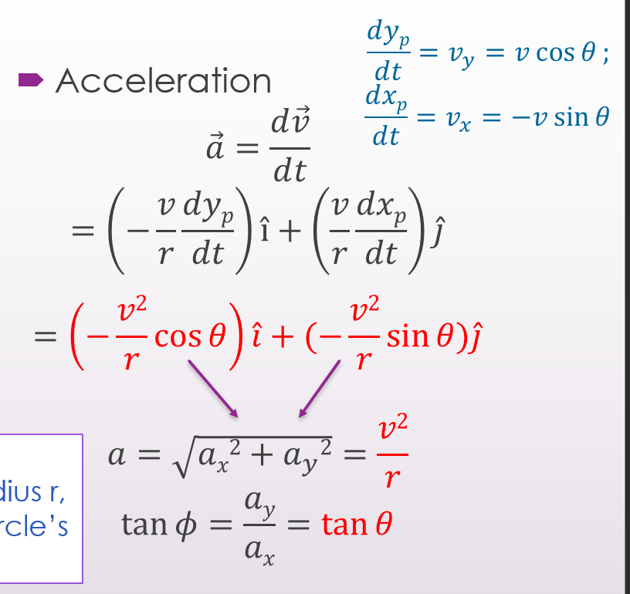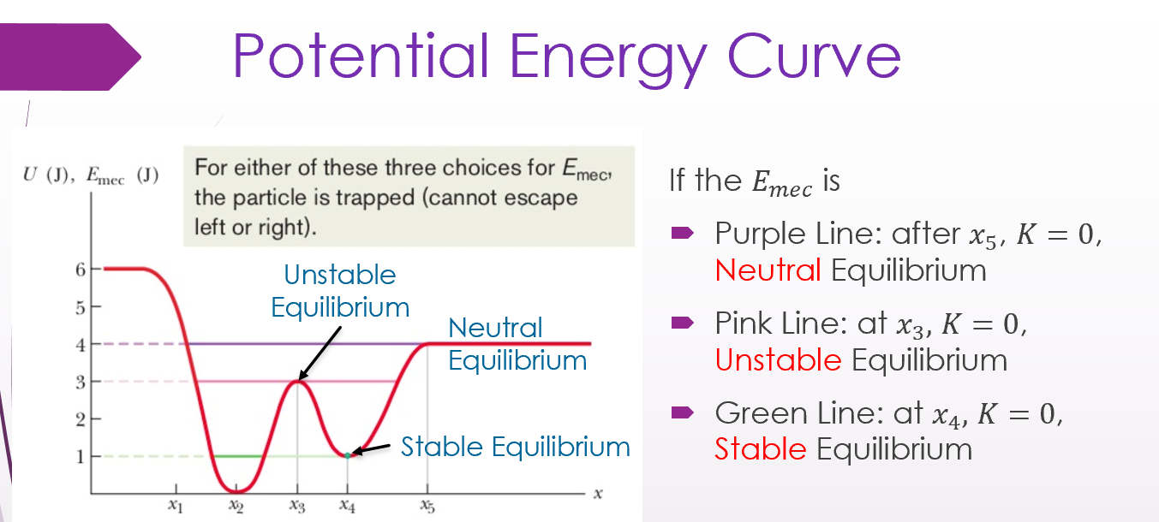
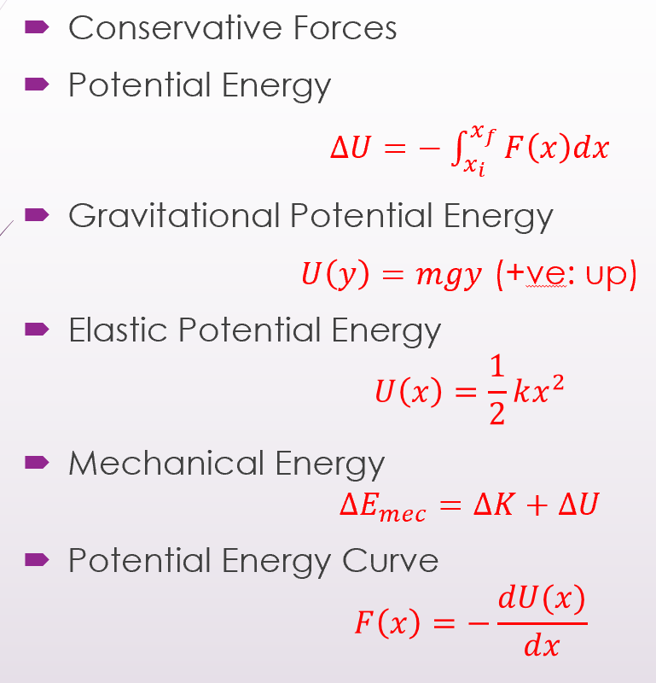
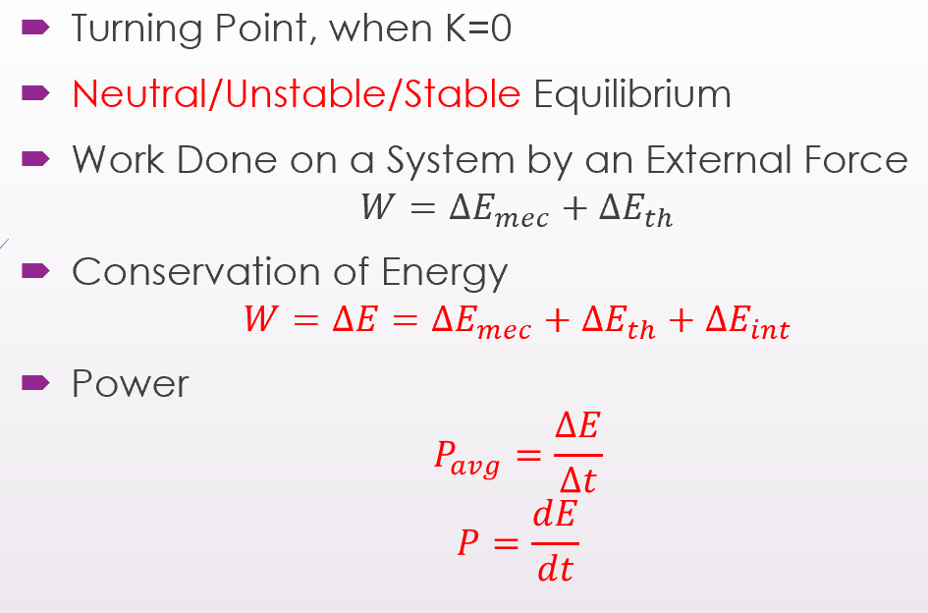
∆E_mec机械能变化量、∆E_th热能变化量、∆E_int内能变化量
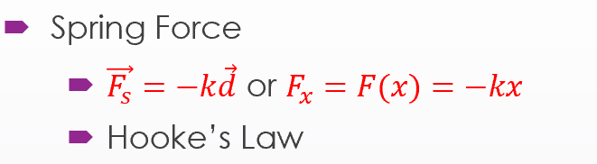

-System with Varying Mass: A Rocket
The ejection of mass from the rocket's rear increases the rocket's speed.
$(a)$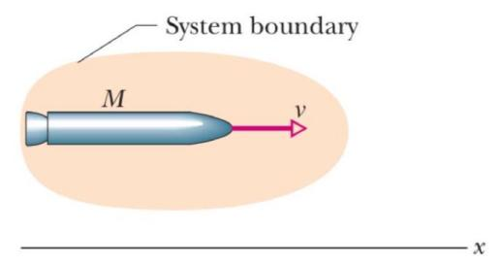
$(b)$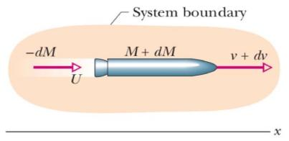
(a)从惯性参考系看，在时间t处质量为M的加速火箭。
(b) 相同，但在时间 t+dt。图中显示了间隔 dt 期间释放的排气产物。- 火箭和排气产品形成一个孤立的系统
-Conserve Momentum
· $Mv=-dMU+(M+dM)(v+dv)$
U: velocity of products relative to frame
dM:-ve
Use relative speed $\left(v_{rel}\right)$ : velocity of rocket relative to products
· $\begin{matrix} & v+dv=v_{rel}+U \\ & U=v+dv -v_{rel} \\ & -dMv_{rel}=Mdv\end{matrix}$
-Rocket Equations
For rockets releasing products:
· $-\frac{dM}{dt}v_{rel}=M\frac{dv}{dt}$
R: Mass rate of fuel consumption $-\frac{dM}{dt}=R;$
$T=Rv_{rel}=Ma$
First Rocket Equation
R $v_{\text{rel }}$ : the Thrust of the rocket engine (T)
· $\begin{matrix}dv=-v_{rel}\frac{dM}{M} \\ \int_{v_{i}}^{v_{f}}{ } dv=-v_{rel}\int_{M_{i}}^{M_{f}}{ } \frac{dM}{M} \\ v_{f}-v_{i}=v_{rel}ln⁡\frac{M_{i}}{M_{f}}\end{matrix}$
The velocity change for a given consumption of fuel as the second rocket equation.

零角位置. · $θ=\frac{s}{r}$ * θ必须使用弧度制
· $ω_{avg}=\frac{θ_{2}-θ_{1}}{t_{2}-t_{1}}=\frac{Δθ}{Δt}$ ($Δθ=θ_{2}-θ_{1}$ 仅对刚体成立)
·$ω=\lim_{Δt→0}{\frac{Δθ}{Δt}}=\frac{dθ}{dt}$
$α_{avg}=\frac{ω_{2}-ω_{1}}{t_{2}-t_{1}}=\frac{Δω}{Δt}$对任意物体都成立
(!!! Right-Hand Rule右手定则 用于 判断 角速度ω和角加速度α 的方向)
For fixed rotational axis,
only two ways of rotation:
Counterclockwise - Positive(+)
Clockwise - Negative(-)
For rotations about different axes: $\vec{θ_{1}}+\vec{θ_{2}}≠\vec{θ_{2}}+\vec{θ_{1}}$
For rotations about a fixed axis: $θ_{1}+θ_{2}=θ_{2}+θ_{1}$
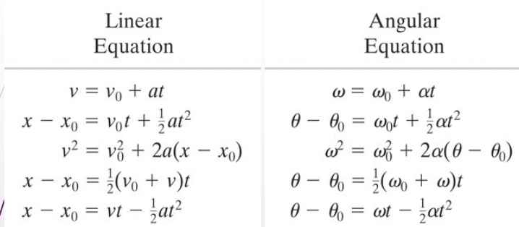
a_{r}: 线性加速度 的 径向分量
· $a_{r}=\frac{v^{2}}{r}=ω^{2}r (radian measure)$
a_{t}: 线性加速度 的 切向分量
· $a_{t}=\frac{dv}{dt}=\frac{dω}{dt}r=αr (radian measure)$
旋转动能$K=\sum{\frac{1}{2}m_{i}}v_{i}^{2}=\frac{1}{2}(\sum{m_{i}r_{i}^{2}})ω^{2}=\frac{1}{2}Iω^{2}$

$I=\sum{m_{i}r_{i}^{2}}=\int{r^{2} dm}$xis
(?? 此处dm可写为 ? dr 的形式，然后在对于r的积分上，下边是相对于旋转轴的负坐标，上边是相对于旋转轴的正坐标 ?)
-The Parallel-Axis Theorem 平行轴定理
Have known the moment of inertia for the center of mass axis (I_{com})
→ Find the moment of inertia for a parallel axis (I)
· $I=I_{com}+Mh^{2}$
h: the perpendicular distance
between the axis that we need & the axis through the center of mass
(these two axes must be parallel; not valid for two arbitrary axes)
M: 物体的总质量
I: 物体绕 任意轴(所需求I的轴) 的转动惯量
I_{com}: 物体绕 过其重心的轴 旋转时的转动惯量
